News
For immediate release

The city of Dollard-des-Ormeaux distributes more than 30,000 masks in high-density areas and to vulnerable people

Dollard-des-Ormeaux, June 18, 2020 - To reduce the number of cases of COVID-19 in its territory, the city of Dollard-des-Ormeaux will distribute over 30,000 masks. Vulnerable people and people living in high-density areas will be able to access the masks for free.
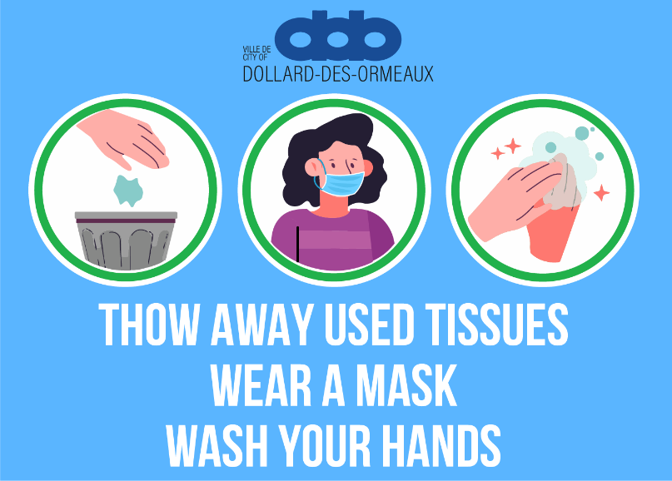
The City sent a letter to each eligible resident, inviting him or her to come and get a pack of five masks. Instructions by the Montreal Public Health authorities for buildings with ten or more units were also included with the letter.
The distribution of masks will be on a “first-come, first-served” basis and proof of residence will be required. Those who receive the letter will be able to come to City Hall Monday to Friday between 8 a.m. and 4 p.m.
As the mayor explains, "our actions today will save lives and ensure that our health care system does not become overwhelmed."
This is just one of many initiatives on the part of the City since the beginning of the pandemic. The ville.ddo.qc.ca/coronavirus page was created to help residents through these difficult times. It contains all the advancements and changes put in place in our territory, as well as a range of services available during this period. The City continues to care for the health, safety and cooperation of its residents to win the battle against the pandemic.
– 30 –
Contact:
Natalia Correa
Section Head of Communications
514-779-9045
ncorrea@ddo.qc.ca — www.ville.ddo.qc.ca
12001, boulevard De Salaberry, Dollard-des-Ormeaux, QC H9B 2A7

